Processes of Memory

What is Processes of Memory
# Source: AI Source: Provided by: [Data Path: Persons Table -> ID Column: 1, Name_En Column: Motasem Essam] -> From: [ChatGPT] on [5/1/2026]
Memory isn’t a single thing—it’s a set of processes your brain uses to take in, store, and later retrieve information. Psychologists usually break it down into three core stages:

1. Encoding (Getting information in)
# Source: AI Source: Provided by: [Data Path: Persons Table -> ID Column: 1, Name_En Column: Motasem Essam] -> From: [ChatGPT] on [5/1/2026]
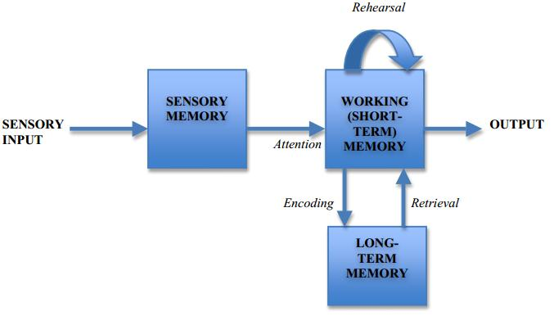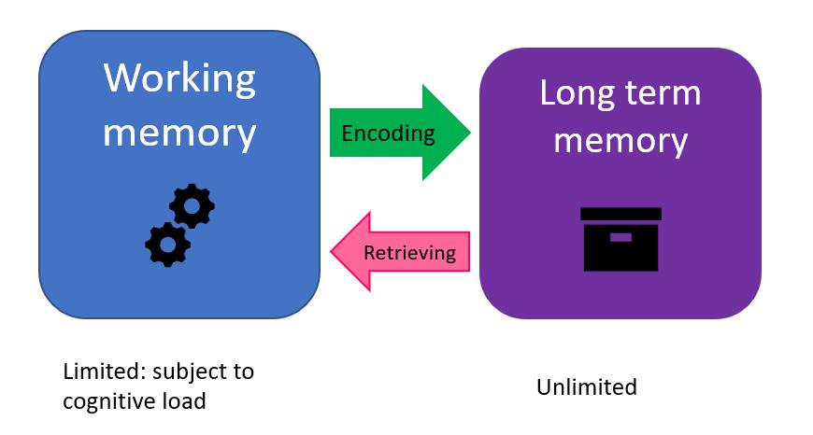
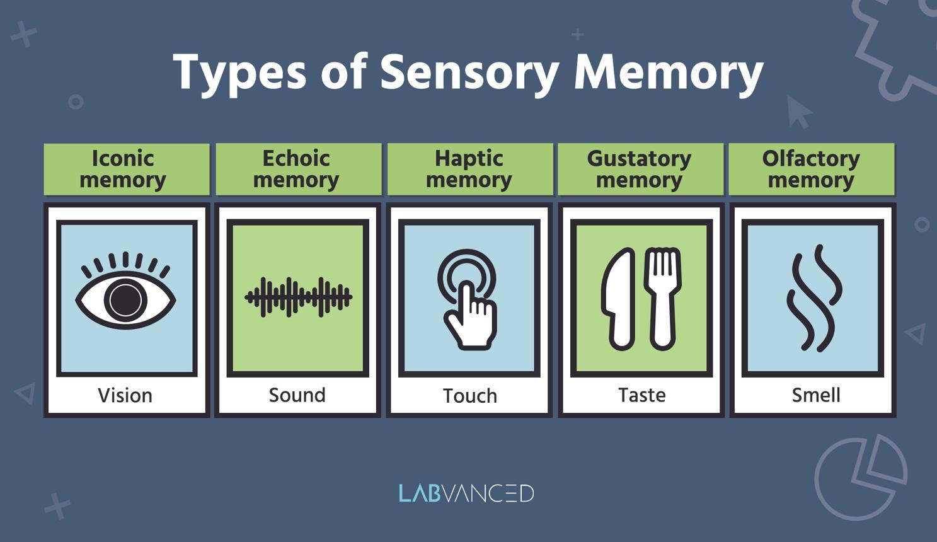
6
Encoding is the first step—transforming sensory input (what you see, hear, feel) into a form your brain can store.
- Types of encoding:
  - Visual (images, faces)
  - Acoustic (sounds, words)
  - Semantic (meaning—this is usually the strongest)
- Key factor: Attention. If you don’t focus on something, it rarely gets encoded well.
Example: Reading a textbook and actually understanding it (semantic encoding) helps you remember it better than just skimming.

2. Storage (Keeping information over time)
# Source: AI Source: Provided by: [Data Path: Persons Table -> ID Column: 1, Name_En Column: Motasem Essam] -> From: [ChatGPT] on [5/1/2026]
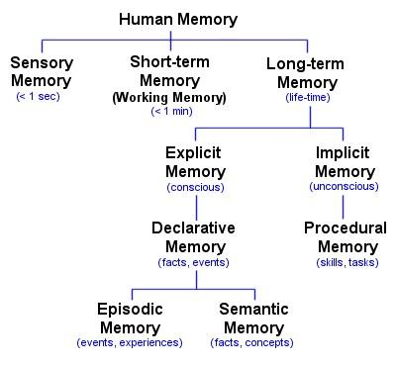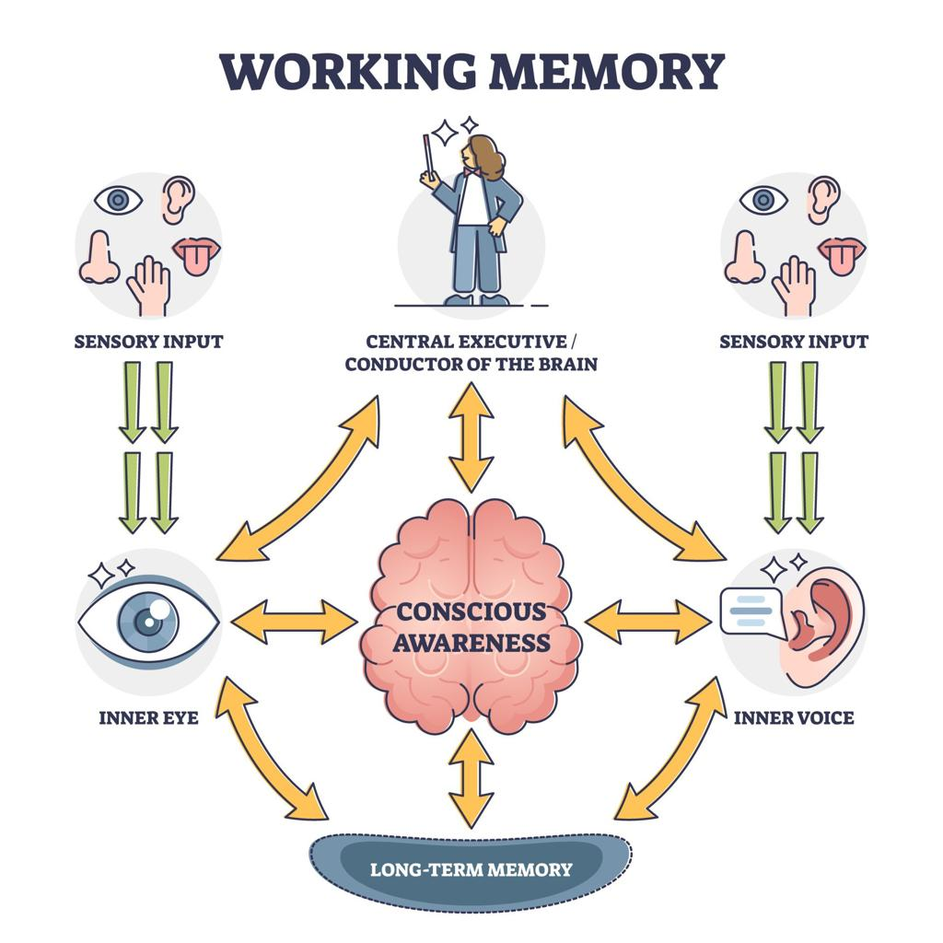
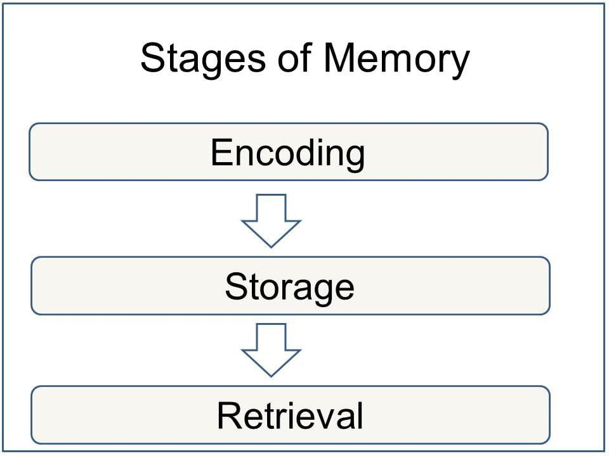
Once encoded, information is stored in different memory systems:
- Sensory memory (milliseconds–seconds): brief snapshot of sensory input
- Short-term / Working memory (seconds–minutes): limited capacity (~7 items)
- Long-term memory (days–lifetime): vast capacity
Long-term memory includes:
- Explicit (declarative): facts and events
- Implicit (procedural): skills like riding a bike
The hippocampus plays a crucial role in forming new long-term memories.

3. Retrieval (Getting information out)
# Source: AI Source: Provided by: [Data Path: Persons Table -> ID Column: 1, Name_En Column: Motasem Essam] -> From: [ChatGPT] on [5/1/2026]
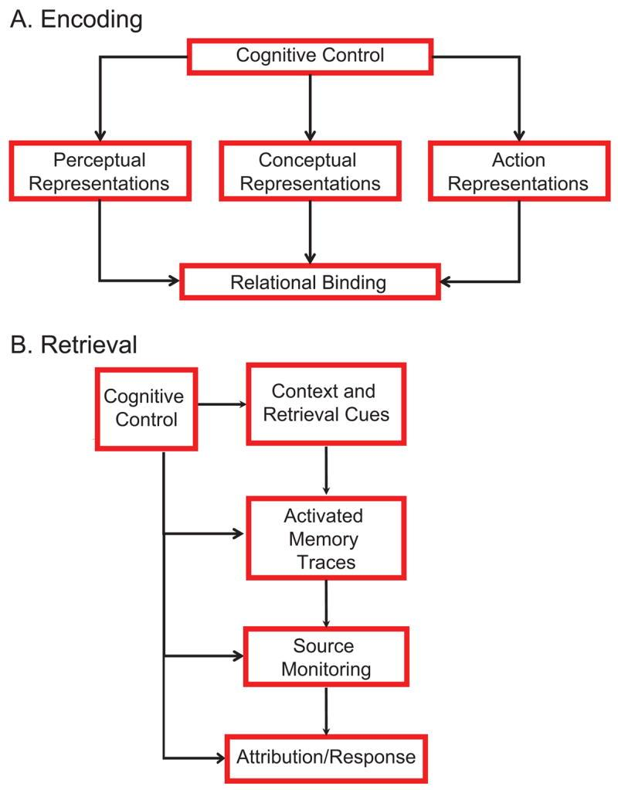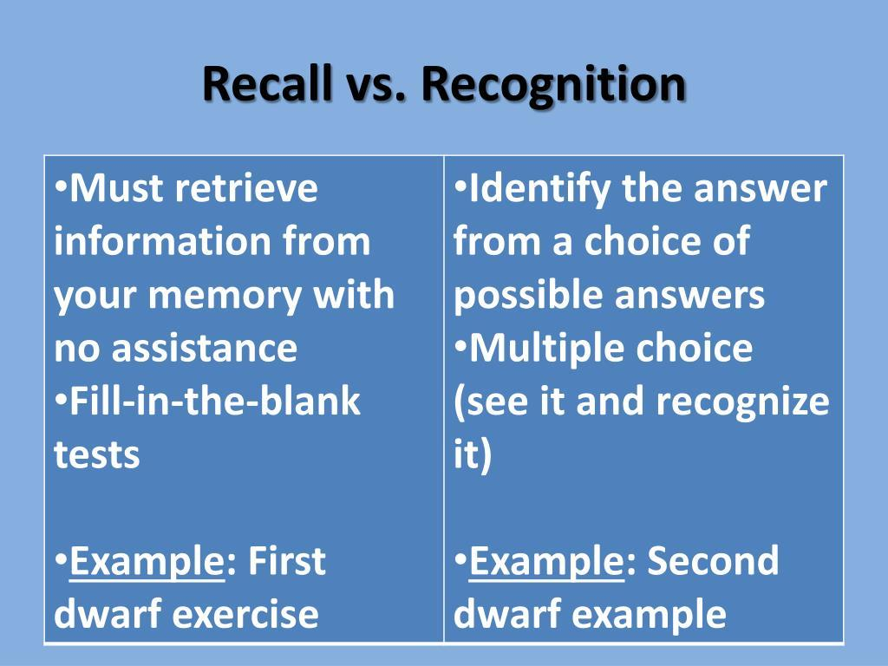
Retrieval is accessing stored information when you need it.
- Recall: retrieving without cues (e.g., essay questions)
- Recognition: identifying correct information (e.g., multiple choice)
- Relearning: faster re-acquisition of forgotten info
Retrieval is often cue-dependent—certain contexts, smells, or emotions can trigger memories.

How the Processes Work Together
# Source: AI Source: Provided by: [Data Path: Persons Table -> ID Column: 1, Name_En Column: Motasem Essam] -> From: [ChatGPT] on [5/1/2026]
Think of memory like a system:
- Encoding = input
- Storage = saving
- Retrieval = output
If any stage is weak (e.g., poor attention during encoding), memory performance suffers.

